GroshopAid- Indoor obstacle avoidance and RFID based shopping aid for visually impaired people

Jyoti Madake, Shweta Munjewar, Rutuja Nagdekar, Mitali Nimase, Shripad Bhatlawande

*Department of Electronics and Telecommunication Engineering*

*Vishwakarma Institute of Technology*

Pune, India

{[jyoti.madake@vit.edu](mailto:jyoti.madake@vit.edu), [shweta.munjewar20@vit.edu](mailto:shweta.munjewar20@vit.edu), [rutuja.nagdekar20@vit.edu](mailto:rutuja.nagdekar20@vit.edu), [mitali.nimase20@vit.edu](mailto:mitali.nimase20@vit.edu), [shripad.bhatlawande@vit.edu](mailto:shripad.bhatlawande@vit.edu) }

***Abstract –Visually impaired people face several challenges when it comes to autonomous shopping. Including difficulties with user interface access, product information retrieval, and payment processes. To address these issues, we proposed a GroshopAid- Indoor obstacle avoidance and RFID based shopping aid system involving an RFID reader, Raspberry pi, a camera and an LCD. The obstacle detection system consists of three classes and uses SIFT and HOG for feature extraction. The feature vector is optimized by applying K-means_clustering and_PCA. The optimized feature_vector is trained using different classifiers. Among them Random _Forest gives the best accuracy of 81%. And in the second part, RFID technology helps to identify and locate products. Each item has an RFID_tag, which can be verified by the user. Once scanned, the system shows the total amount of items.***

***Keywords - RFID_reader, RFID_tags, _Raspberry Pi, Camera, LCD***

1. Introduction

GroshopAid is an innovative system designed to provide an inclusive shopping experience for visually impaired people. The system combines obstacle avoidance technology with RFID based product identification, aiming to overcome the difficulties experienced by them consists of accessing and navigating the user interface, retrieving product information, and completing payment. To address this issue, we developed a Human-Friendly Smart Trolley with an Autonomous Billing System. To create a connected environment, the smart shopping system incorporates RFID tags, readers, Wireless Fidelity (Wi-Fi), LCD and Speaker. An LCD-based application allows users to modify product prices, saving customers time [1]. In the obstacle detection system, a 1200 image dataset is used for the pre-trained model with different sizes and categories into 3 classes, Person, Rack and Trolley. K-Means and PCA are used for Dimensionality Reduction*.* The system uses Python-based code that contains pre-trained classification models. It then uses the OpenCV module to segment the image into frames, compares the obtained frames with the pre-trained module and outputs the appropriate labels [2].

This_paper is arranged in the following way. Literature survey is presented in Sec. II. Methodology for obstacle detection and RFID interfacing is presented in Sec. III, followed by results and discussion in Sec. IV and some_concluding_remarks_ in Sec. V.

# Literature Survey

In the realm of enhanced shopping experiences for visually impaired individuals, several innovative systems have been developed, incorporating a variety of technologies. This literature survey explores existing research, methodologies, and advancements, highlighting the benefits, challenges, and future prospects of this innovative approach. It establishes a foundation for the project's development and contribution to autonomous shopping systems. This literature review explores the key advancements in the field, focusing on the integration of RFID, ZigBee communication, and mobile technology. One notable implementation [1] presents a system that utilizes an microcontroller and an EM18 module to read unique identifiers from RFID tags. Additionally, the system includes buzzer and LED indicators to provide auditory and visual feedback. Another remarkable solution, known as Blind Shopping, merges the capabilities of an RFID reader and mobile technology to enable user navigation and product recognition [2]. The system raised QR_codes on items, and the camera of an Android phone to recognize products. Building on these advancements, a proposed centralized and automated billing system capitalizes on the potential of RFID and ZigBee communication technologies [3]. The system utilizes RFID tags assigned to each product and incorporates a Product Identification Device (PID) within shopping carts. The PID consists of a microcontroller, LCD display, EEPROM memory, RFID reader, and a ZigBee module. This paper raises numerous privacy concerns about RFID technology [4]. The proposed system uses RFID tags to identify persons and semi-autonomous control allows the robot to build rapport with customers providing effective shopping information. The results of the survey suggest that customers used the collective information of the robot and went shopping based on that information [5].

One notable research work [6] delves into the creation of a digital billing system specifically designed for shopping carts. The system utilizes RFID tags or cards assigned to products within the trolley to store purchase information in a database. Billing details are then generated on an LCD screen attached to the cart and on the server, streamlining the transaction process. Another proposed solution introduces a smart shopping cart system that leverages RFID tags, RFID readers, and ZigBee technology to enhance the overall shopping experience [7]. while the shopping trolleys are connect with an RFID reader, an attached ZigBee module, and an anti-theft RFID reader. This combination enables seamless product identification and anti-theft measures. To offer a novel and cost-efficient approach, the authors propose a transition from cart-level scanning to aisle-level scanning, facilitated by the implementation of RFID middleware. This shift enhances accuracy and reduces processing times. Additionally, the paper provides insights into the system architecture, RFID stack, and specific implementation details of each component, and explores various RFID tag technologies [8]. It offers an RFID tutorial which answers questions related to RFID. It describes different RFID applications and the challenges and problems one faces while implementing RFID technology [9]. This passage describes a proposed UHF RFID-based shopping cart system. The proposed system, called "Smart Trolleys," uses UHF RFID tags with unique identification codes and UHF antennas mounted on shopping carts to track and process shopping data in real-time [10].

An RFID reader mounted to the trolley reads the code, and the identified cost is shown on an LCD screen[11]. The Raspberry Pi and Pi Cam are used to monitor customers' activity. Through the use of Bluetooth technology on Apple and Android smartphones, the Pi Cam recognizes the colour of the customer's wristband and tracks their activity through a smartwatch app. This study [12] [13] [15] [20] describes a sophisticated retail system that utilizes RFID-enabled smart carts and a billing mechanism that is automated. A reader displays the product ID, quantity, and price when a product is placed in the trolley. Another RF reader broadcasts the product ID when a product is withdrawn from the cart. The remote computer receives the product and billing information, along with the cart ID. Charging is programmed within the cart, which saves time for the customer and reduces congestion at the charging counter.

An NLISC is being established to offer a technology-oriented, cost-effective service. LDC is utilized for real-time positioning of the shopping cart within the shopping area,while SCC keeps the connection to the main server alive [14]. The user interface is handled by UIDC, and billing and inventory management are handled by ABI MC. According to the study [16], when an item is put in SSC, it can be instantly scanned by a trolley connected with the reader. For this project, a prototype system is provided to test the functionality, as well as a secure communication protocol. Furthermore, UHF RFID technology is used to improve shopping experiences, and security concerns are handled as part of an SSC.

The billing process is handled by AB, and the cart communicates with the billing counter server via RF transmission [17]. In order to determine whether a product has been placed in the basket or not, RFID technology is combined with infrared sensors [18]. The system is linked to a Raspberry Pi with built-in Wi-Fi in order to communicate with an Amazon RDS database. Clients can keep track of their transactions by hosting them on an Amazon EC2 instance using a Django Web Application. Each item in a smart shopping basket will come with a mobile device equipped with a barcode scanner [19]. When customers scan products, the mobile device records and displays the price and item name. The final amount of the items will be determined and saved in the microcontroller's memory.

A less-price, easily implemented solution for people-assisted shopping consists of an indoor navigation system based on RFID and mobile phones and a QR-Code-based product recogniser [21]. This paper discusses robot localization, navigation, and collision avoidance. The software consists of an Intel NUC with a Core-i77567U processor that does all onboard computations. Robots can autonomously navigate, localise, and identify the items on a shelf using CNN [22]. The suggested approach, which only employs passive RFID, uses trigonometric functions and IC tag coordinates that are arranged in regular grid-like patterns to more precisely estimate the robot's location and orientation. Allowing navigation and projecting product information from an RFID-equipped robot's image sensor onto a 360-degree panorama [23]. It has client- and server-side components; the user interface is on the client side. RFID host software is included on the server side. Once it has been recognised, the robot will pick it up and use a line follower module to move to the desired location [24]. The PIC microcontroller and RFID reader communicate in half duplex mode & reads RFID reader data also displayed on the LCD [25].

By eliminating stock-outs, RFID can increase product availability. It can also speed up the checkout process by reducing lineups or replacing traditional Electronic Article Surveillance [26]. ISAS can track and recognize customers in real-time. It can navigate and localise products that customers want to buy. ISAS will also provide product information and let customers decide what they want to buy using techniques, data mining and DL [27]. The Arduino Uno acts as a middleman microcontroller, controlling RFID technology and facilitating communication between RFID components, which involves the Android mobile application, through the Bluetooth module. The proposed system offers customers the ability to access and log into the system through diverse methods, ensuring the protection of their privacy. This is facilitated by an Android mobile application [28]. The classification of VIP members and customer retention rate are predicted using an ANN. The statistics and decision tree approaches are inferior to the artificial intelligence technique [29]. The trolley is equipped with an automatic billing system and moves in accordance with user commands via an Android application installed on the customer's mobile device. The customer's purchased goods and their costs will be updated automatically as well as sent to the shop's administrative system via Bluetooth(IoT). The automatic payment procedure may be completed using an (RFID) tag and reader, and obstacle avoidance has also been included to increase trolley effectiveness [30].

While the passage discusses enhanced shopping experiences for visually impaired individuals, it does not provide detailed information about specific accessibility features or considerations in the systems mentioned. The usability and user interface design of these systems, especially for individuals with limited technical expertise or disabilities will be difficult. Considering these issues we developed a system which focuses on delivering a user-friendly interface and a streamlined system with minimal complexity. By prioritizing simplicity and ease of use, we aim to provide an intuitive shopping experience that caters to a wide range of users.

1. METHODOLOGY

The proposed_system is divided within two sections : I] Obstacle Detection and Avoidance II] Shopping item recognition using RFID tags

1. Obstacle_Detection and_Avoidance Subsystem

The_paper presents GroshopAid- Indoor obstacle_ avoidance using a camera for visually impaired people. The system guides the detection on I] Person II] Rack III] Trolley

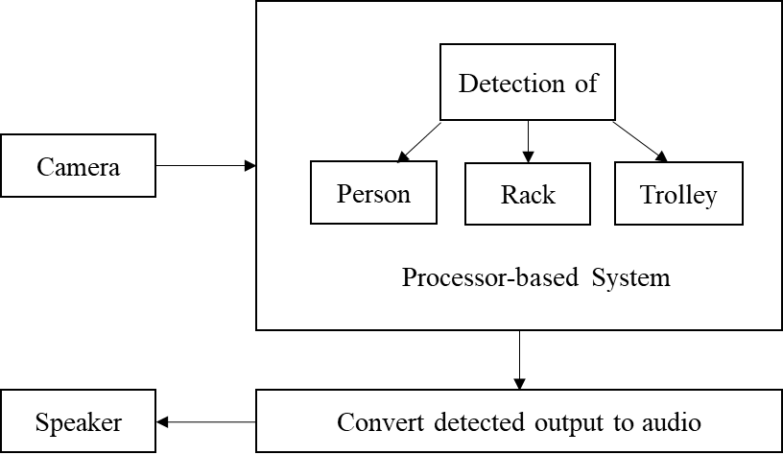

Fig.1.Block_Diagram of Object Detection

The captured environment from the camera_is received by the Processor-based System. Person, Rack, and Trolley are classified and detected by the processor-based system. and then convert detected output to audio by using the speaker.

*A. Data_Acquisition and_Pre-Processing*

The dataset involves 1200 images and has three classes such as Person, Rack and Trolley. Each consists of 300 images. The details of the dataset are displayed in TABLE_I.

TABLE I: DESCRIPTION OF THE. DATASET

| Sr_No. | Class Name | Count of images |
| --- | --- | --- |
| 1 | Person | 300 |
| 2 | Rack | 300 |
| 3 | Trolley | 300 |
| 4 | Other | 300 |
|  | Total | 1200 |

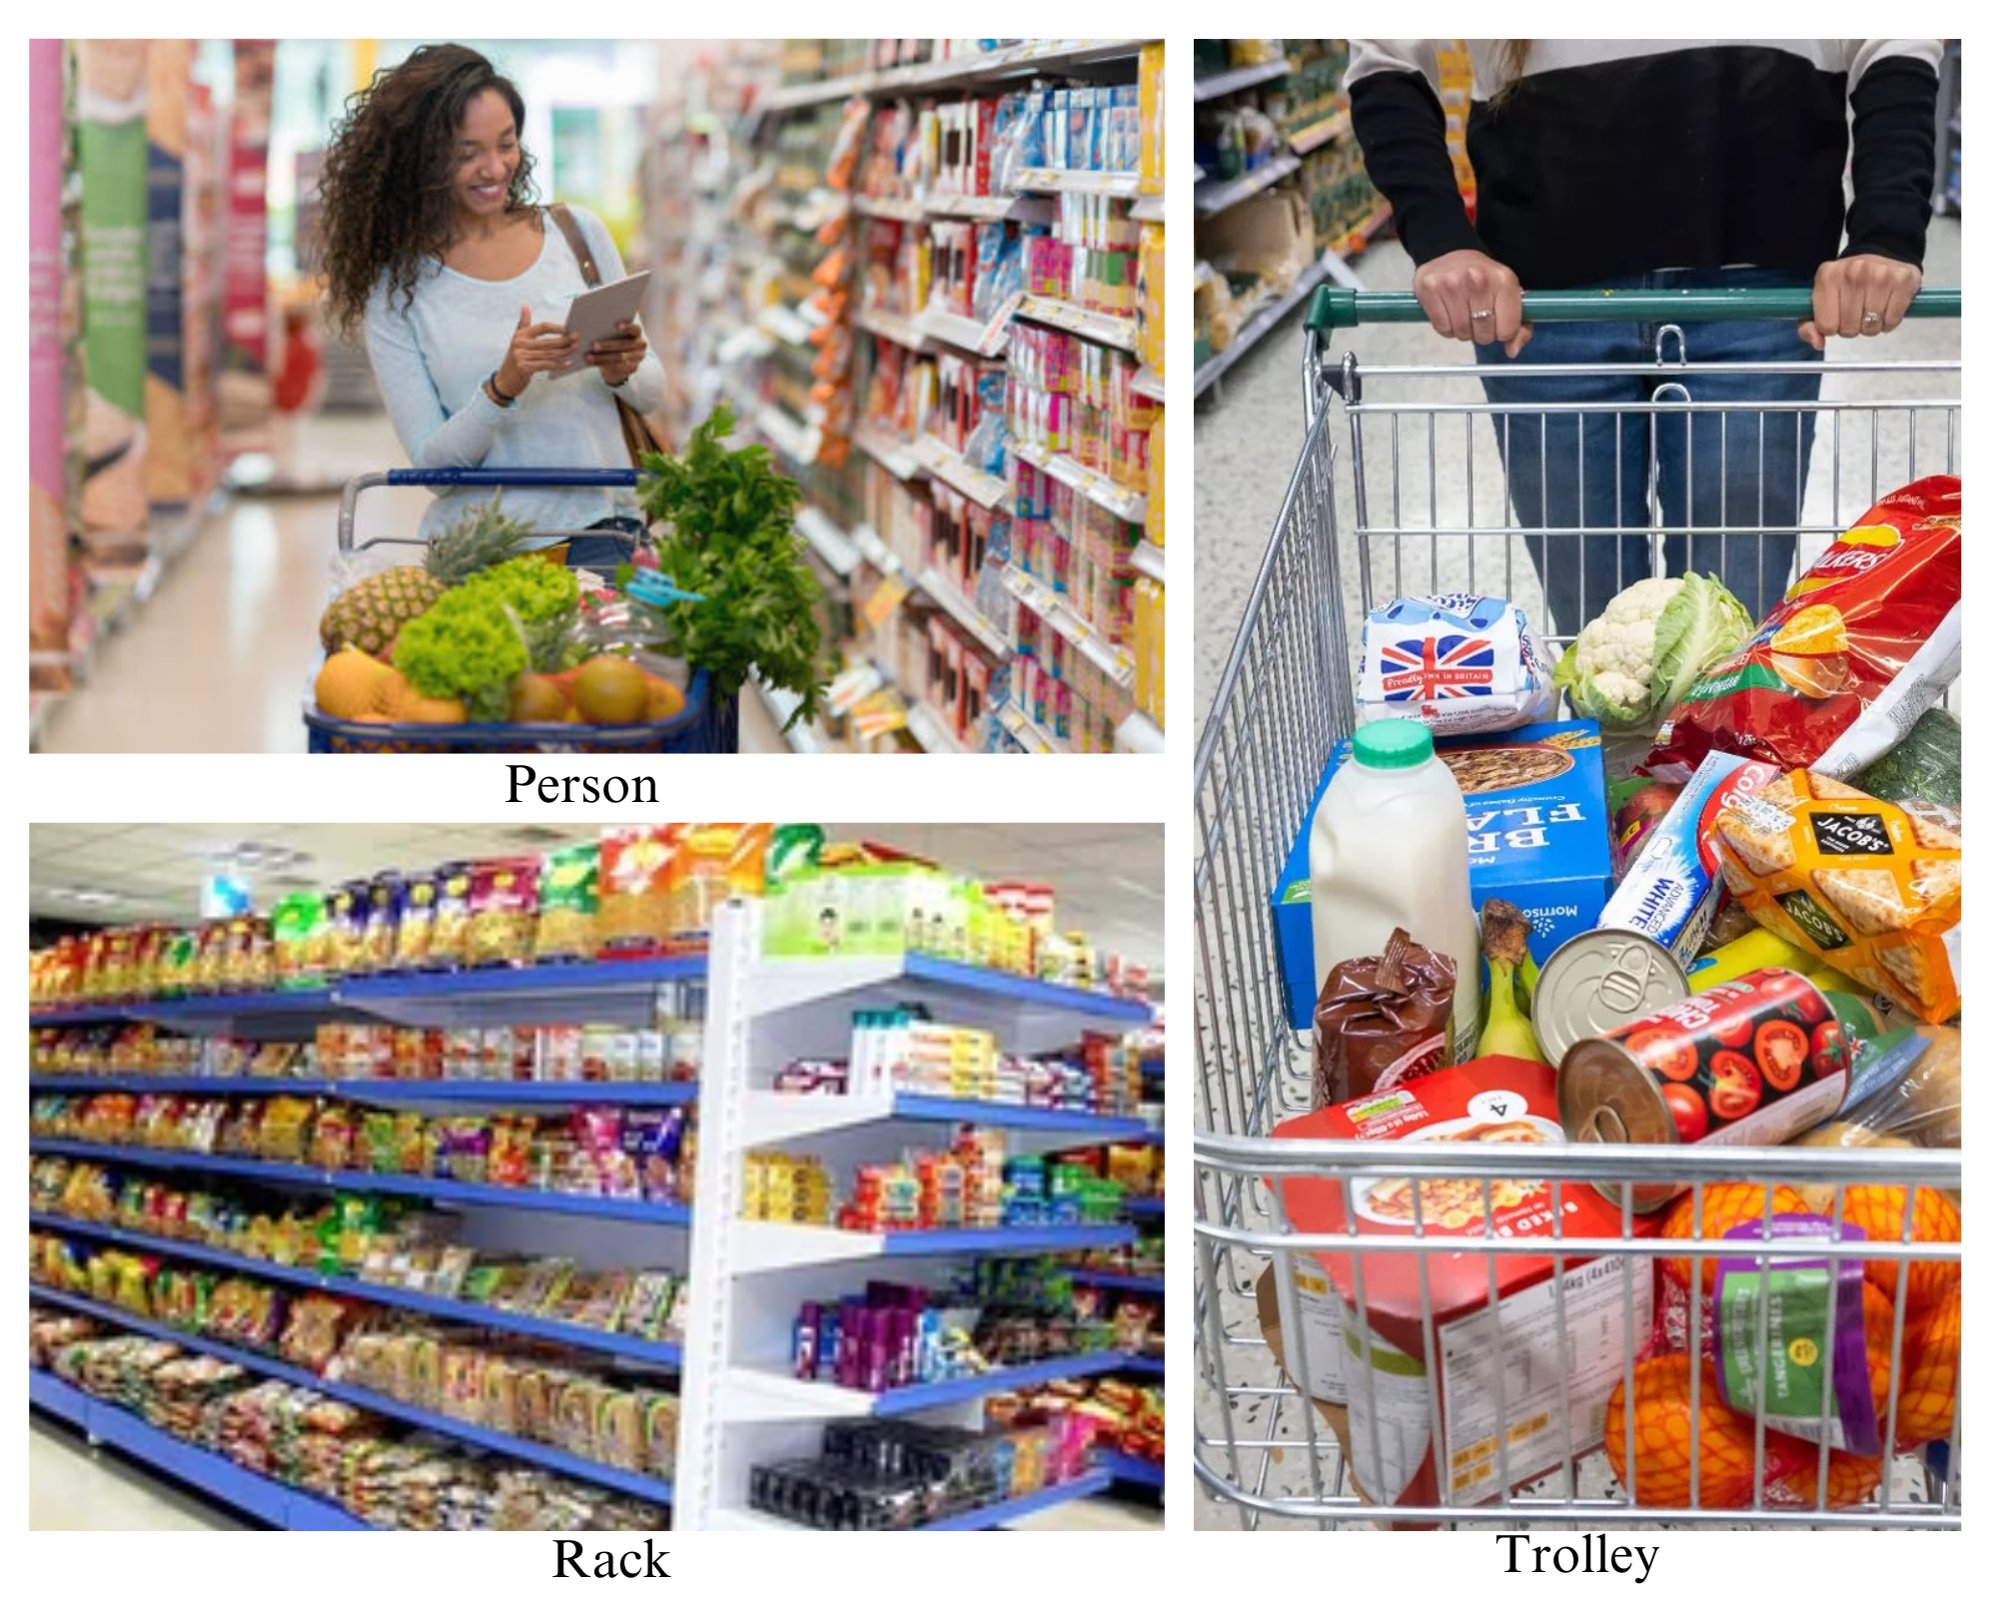

Fig.2. Dataset Images

Fig.2. shows the sample images from the data collection and to enhance the correctness and interpretability, pre-processing is used on raw data, we can address data quality issues, standardize data representations. so, The images were first resized to 512 x 512 pixels and subsequently transformed into grayscale.

## *B. Object Recognition*

i. Feature Extraction using SIFT

The model presents the process of extracting features from descriptors, specifically using the (SIFT) algorithm as depicted in Algorithm. A comparable method was employed to extract SIFT features in a similar manner.

| Algorithm: Feature extraction using SIFT |
| --- |
| Input: Obstacle images (1200) |
| Output: Feature vector (1638768 x 128) |
| Initialization:  1. Specify the path of the dataset.  2. Use a for loop to iterate over each image in the dataset.  3. Resize the image to dimensions 512 x 512.  4. Convert the image to grayscale.  5. Extract features from the image.  6. Append the extracted features to a CSV file.  7. End the inner for loop.  8. Append the CSV file with the features.  9. End the outer loop.  10. The final feature vector has dimensions 1638768 x 128. |

The_ SIFT is a commonly used feature_extraction technique in-image classification problems. SIFT critical points are searched across several image scales using a technique known_as_the_(DOG) pyramid. Key_spots_are selected_by selecting local_maxima_points in the_3D vicinity of_the_image_scale_pyramid.

After SIFT feature_ extraction, we got the feature vector size as 1638768 x 128 which is a very large value. This is going to_ make our system complex. Therefore, we have used the_ K-means_ algorithm_ for dimensionality reduction which is an unsupervised algorithm. In contrast to supervised learning, this clustering does not use labelled data. K-Means divides objects into clusters with objects in common and different from things in another cluster.

ii. Feature Extraction using HOG

HOG is a feature extraction technique widely used in computer vision and image processing. It captures the local shape and edge information from an image by analyzing the distribution of gradient orientations. HOG divides the image into small cells and computes the gradient magnitudes and orientations within each cell. These gradient histograms_ are then concatenated_ to_ form a feature vector that represents the image's local structure.

| Algorithm: Feature extraction using HOG |
| --- |
| Input: Obstacle images (1200) |
| Output: Feature vector (1638768 × 128) |
| Initialization:  1.Specify the correct path for the dataset.  2. Use a for loop to iterate over each image in the dataset.  3. Resize the image to dimensions 128 x 64.  4. Convert the RGB images to grayscale.  5. Extract features using HOG parameters  6. Append the extracted features to a CSV file  7. End the inner for loop.  8. Append all the extracted features from the images to a final CSV file.  9. End the outer loop.  10. The final HOG feature vector has dimensions 226440 x 1. |

After HOG feature extraction, we got the feature vector size as 226440 x 1 which is a very large value. This is going to make our system complex. Therefore, we have used the K-means algorithm for dimensionality reduction which is an unsupervised algorithm. In contrast to supervised learning, this clustering does not use labelled data. K-Means clustering partitions objects into clusters based on their similarities and differences from other objects in separate clusters.

In order to enhance the performance of the proposed system and enhance the representation of features, we combined SIFT and HOG features.

*C. Optimization of feature vector*

We employed K-means and PCA to reduce the dimensions of the feature vector derived from SIFT and HOG. The dimensionality reduction was achieved through the utilization of the k-means technique. To determine the most suitable number of clusters, we utilized the elbow method in k-means clustering. This approach assesses the distortion present within the clusters. Additionally, we utilized Principal Component Analysis (PCA) to reduce the feature size of the vector. It can be used as a filter for noisy data. In the PCA technique, we will determine the number of components which will be needed for describing data. We determined N-components by using the cumulative explained variance ratio function. The iterative algorithm divides the unlabeled dataset into k distinct clusters, where each cluster contains a single dataset and shares a common set of characteristics.

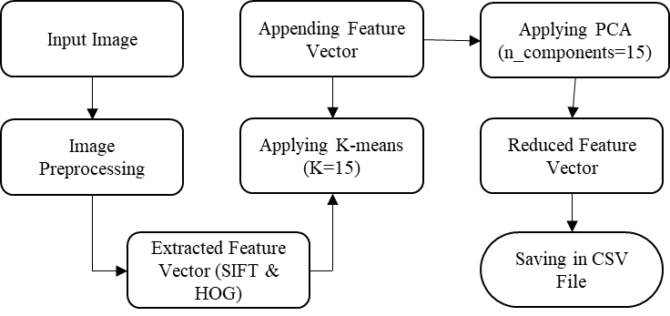

Fig. 3 Compilation of feature vectors using the SIFT and HOG

| Algorithm: Dimensionality Reduction using PCA |
| --- |
| Input: Feature Vector (1638768 x 128) |
| Output: Reduced Feature vector (1200 x 15) |

Initialization:

1. Perform K-means clustering on the feature vector (k=15) in a loop process.

2. For each image in the specified path, do the following:

a. Apply k-means prediction using the clusters obtained.

b. Reduce the number of components.

c. Build a PCA model.

d. Append the HOG and SIFT features to the final PCA model and save them in a CSV file to form the feature vector.

6. End the loop.

7. Standardize the feature vector using the standard scalar method.

8. Reduce the size of the feature vector.

9. Return the optimized feature vector as the output, with dimensions (1200, 15).

____________________________________________________________

*D. Obstacle Recognition*

The proposed system worked on three different classifiers such as Random_ Forest, Decision_ Tree and Logistic_ Regression. Among them, the Random_ Forest classifier gives the best accuracy of 81%.

1. Random_ Forest

The Random_ Forest algorithm is a supervised_ machine_ learning_ approach that entails training numerous decision trees on randomly selected subsets of the training data. The trees are grown to a maximum depth or until the stopping criterion is met. The ultimate prediction is determined by aggregating the majority vote from the trained decision trees. so, on testing the dataset with random forest, we obtained an accuracy of 81%. In equation (1), the branching of data from each node in the Random Forest algorithm is determined by the MSE (Mean Squared Error). It is expressed as follows:

$MSE=\frac{1}{N}\sum_{i=1}^{N}{}(ki-li)^{2}$------ (1)

In this context, N denotes the total number_ of data_ points, ‘ki’ represents the_ value predicted by the_ model, and ‘li’ corresponds to the original value of dat_ point i.

1. Decision Tree

In the realm of machine learning and decision analysis, a decision tree is utilized to predict the outcome of a decision or a series of decisions. It is represented as a tree-like graph or model.

T(x) = f(x,θ) ------(2)

where T(x) is the output (decision or prediction) for a given input x, f(x, θ) denotes the mapping of input x to the output T(x), where θ represents the parameters or splitting criteria utilized within the decision tree.

1. Logistic_ Regression

Logistic Regression_ is a statistical technique utilized_ to estimate the probability of a binary outcome (such as success or failure) by considering a set of predictor variables. It is commonly used in machine learning and data analysis to make predictions and classify data into one of two categories.The basic equation for logistic regression can be represented as follows:

P(Y=_1|X) = e(β0_ + β1*X) / (1_ + e(β0 + β1_*X)) ------(3)

P(Y=1|X) denotes the probability of the binary outcome Y=1 given the input variables X. The term β0 corresponds to the intercept, β1 signifies the coefficient or weight assigned to the predictor variable X, and the base of the natural logarithm is represented by e.

2. Shopping item recognition using RFID

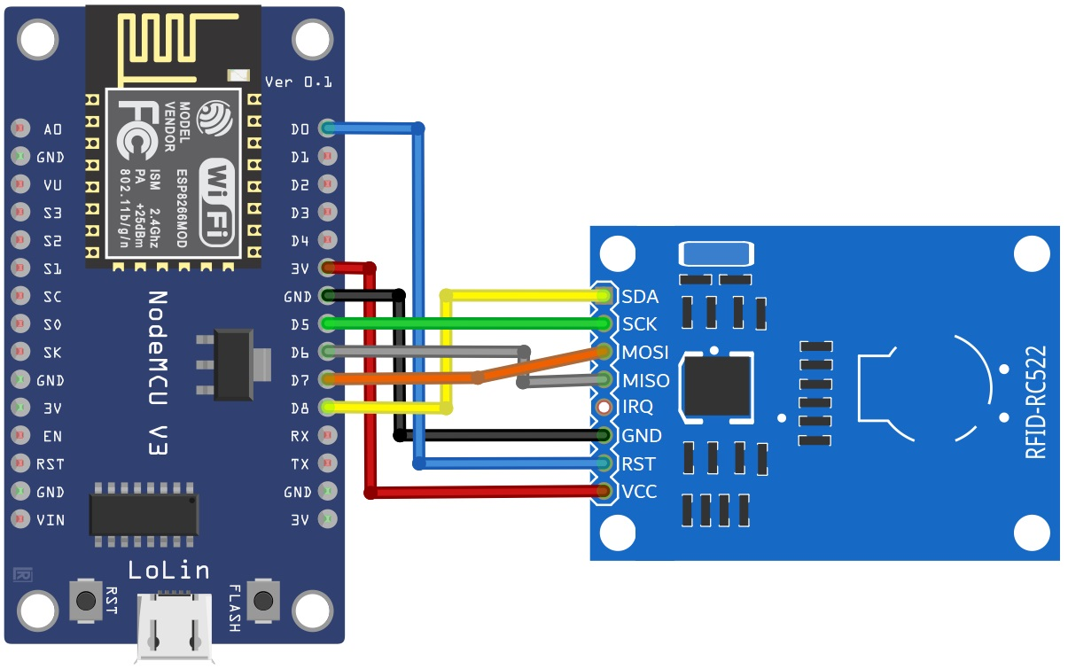

Fig.4. Interfacing RFID with NodeMCU

The methodology for interfacing RFID with NodeMCU and transferring its data to a web server using PHP, MySQL, and the HTTP POST method involves several key steps. First, the hardware setup is performed by connecting the RFID module to the NodeMCU board with the appropriate wiring connections as shown in fig 4. The RFID reader module used here is RC522 which is a popular RFID module commonly used for communication between RFID tags and microcontrollers like Arduino or NodeMCU. It operates at 13.56 MHz frequency and utilizes the ISO/IEC 14443A standard for RFID communication. The RFID reader communicates with NodeMCU via SPI protocol.

Once the hardware is set up, the software setup is executed by configuring the Arduino IDE, installing the required libraries like the MFRC522 library, and selecting the appropriate board type and port. The board_ type used is NodeMCU_ 1.0 (ESP-12E Module) and port number is 3 . The baud rate used for serial monitors is 115200 Hz.

Next, the code is developed in the Arduino IDE to initialize the RFID module, configure necessary settings, and create functions to read RFID tags and extract the tag data. To enable communication with the web server, a PHP script is set up on the server side. This script is responsible for handling the incoming data from NodeMCU and establishing a connection with the MySQL database for data storage and retrieval.

The HTTP POST method is implemented in the NodeMCU code to send the RFID tag data to the web server. The HTTP POST request is constructed with the appropriate headers and payload containing the RFID data. On the server side, the PHP script receives the HTTP POST request, extracts the RFID data, performs validation and sanitization, and securely stores the data in the MySQL database.

Thorough testing is conducted by scanning RFID tags and verifying that the_ data is successfully transferred_ to the web server and stored in the MySQL database. Once the testing phase is completed, the finalized code is uploaded to the NodeMCU board and the PHP script is deployed on the web server for production use.

By following this, RFID data can be seamlessly interfaced with NodeMCU and transmitted to a web server using PHP, MySQL, and the HTTP POST method.

The algorithm for the above approach is as follows:

| Algorithm: Interfacing NodeMCU with RFID |
| --- |
| Input: RC522 module and NodeMCU. |
| Output: Unique identifier (UID), Object detected and Total amount |
| Initialization:  1. Connect RC522 module to NodeMCU.  2. Configure SPI communication protocol.  3. Import necessary libraries (e.g.,MFRC522).  4. Initialize RC522 module using MFRC522 library.  5. Continuously check for RFID card presence.  6. Read the unique identifier (UID) of the detected card.  7. Process RFID data (e.g., store or send to a web server). |

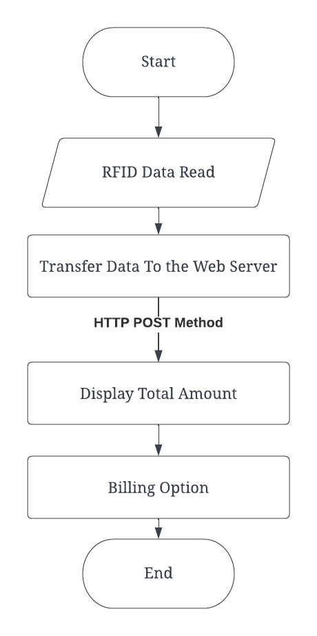

Fig.5. RFID Flow Diagram

In Fig.5 Flow diagram for RFID is given where data will be read first and then will be transferred to the web server using HTTP POST method. User can see the total amount on website and finally the billing option will be displayed.

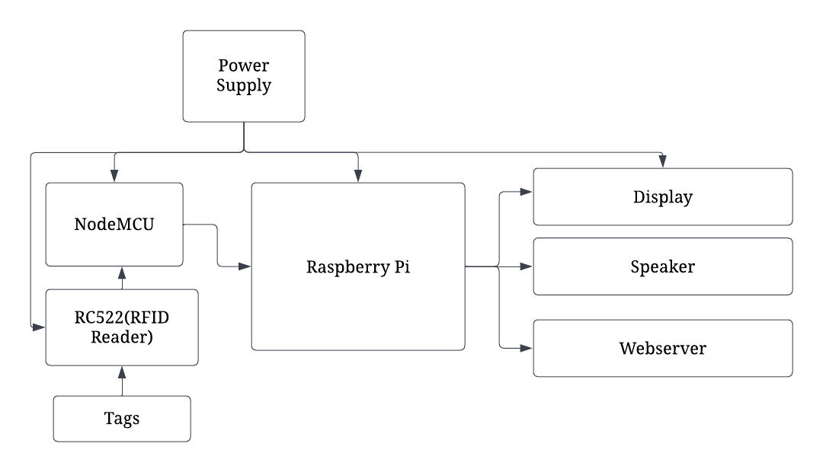

Fig.6. Block Diagram

In Fig.6 Raspberry pi and Node MCU are integrated where input to the system are tags. The output from the system is display showing the total amount, speaker and webserver

IV. RESULTS AND DISCUSSION

The proposed system is composed of two main components: I) Obstacle Detection and Avoidance, and II) Shopping Item Recognition using RFID tags. This research introduces an innovative solution called GroshopAid, which focuses on indoor obstacle avoidance for visually impaired individuals, employing a camera. The system effectively detects three key elements: I) People, II) Racks, and III) Trolleys, providing guidance to the users. To evaluate the system's performance, the dataset is divided into training and testing subsets. In this study, two popular models, namely SIFT and HOG, are compared based on their testing accuracies. These models serve as feature descriptors, enabling effective object recognition In this study, two popular models, namely SIFT and HOG, are compared based on their testing accuracies. These models serve as feature descriptors, enabling effective object recognition. Activity classification of Person, Rack and Trolley is done using the Random Forest , Logistic Regression and Decision Tree classifiers. Using SIFT and HOG parameters, Random Forest has the maximum testing accuracy of 81%, Logistic Regression exhibited a testing accuracy of 80%, while the Decision Tree classifier achieved 75% accuracy.

In this setup, we will utilize two distinct controllers, namely Raspberry Pi and NodeMCU. The system incorporates multiple components such as a display, speaker, RFID reader, and RFID tags integrated into various objects. Users can conveniently access the autonomous shopping website by logging in to their accounts, where they gain visibility into their purchased items and the corresponding total amount to be paid. This seamless platform allows individuals to effortlessly manage their shopping transactions and stay informed about their financial obligations.

TABLE II: TESTING ACCURACY

| Classifiers | Testing Accuracy of SIFT |
| --- | --- |
| Random Forest | 81% |
| Logistic Regression | 80% |
| Decision Tree | 75% |

TABLE II compares the performance of different classifiers based on testing accuracies and Fig.7. represents the graph in between different classifiers.

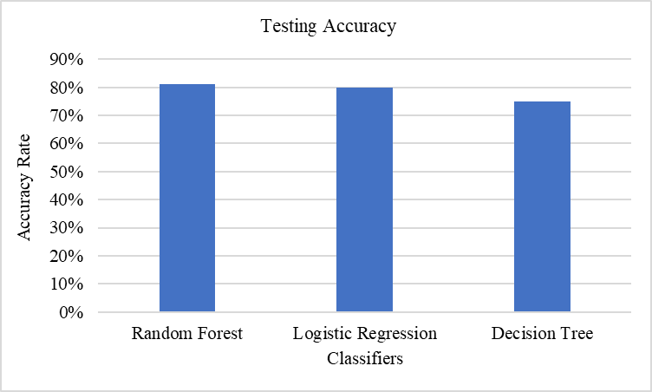

Fig.7. Graphical representation of different classifiers

TABLE III: PERFORMANCE PARAMETER

| Classifier | F1 Score | Recall  Score | Precision Score | Sensitivity | Specificity |
| --- | --- | --- | --- | --- | --- |
| Random Forest | 70% | 65% | 77% | 84% | 85% |
| Logistic Regression | 60% | 63% | 58% | 70% | 65% |
| Decision Tree | 68% | 70% | 64% | 75% | 93% |

TABLE III compares various classifiers using SIFT and HOG metrics such as F1 Score, Recall Score, Precision Score, Sensitivity, and Specificity.

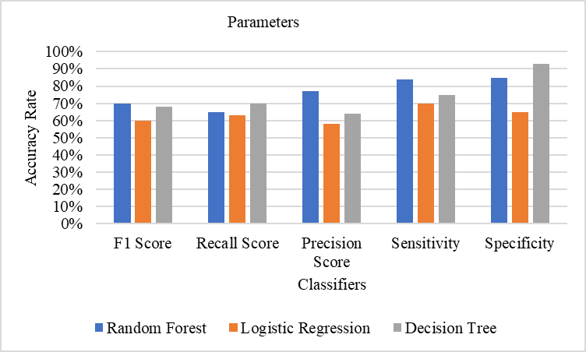

Fig.8. Graphical representation of parameters

Fig.8. represents the graph in between different classifiers.

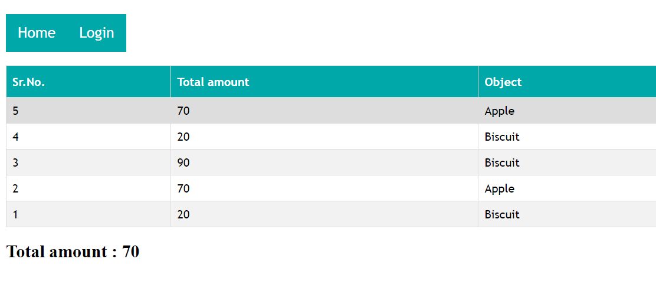

Fig.9..Sending data from NodeMCU to website

In Fig.9, Web Server for autonomous shopping is shown where information of each transaction is displayed. On the website, users can register and login. Here the total amount, detected object, time and date for every scan is shown.

V. CONCLUSION

GroshopAid- Indoor obstacle avoidance and RFID based shopping aid for visually impaired people using a camera is a promising technology. With the SIFT and HOG descriptors, the approach provides the greatest accuracy for the Random Forest classifier. With a commendable testing accuracy of 81%, the Random Forest model demonstrates remarkable performance. This high accuracy reflects the proposed system's ability to provide precise and reliable responses. Systems predict the wrong class for blurred and noisy images. Detection and classification of the objects can be improved in the future using large datasets. The system can be used for real-time monitoring also. Better classifiers can increase the system's accuracy. Also, the rate of the system can be improved. Overall, The system has the potential to significantly improve the quality of life for visually impaired individuals, empowering them to navigate indoor environments and engage in shopping activities with increased independence and confidence.

References

1. Sanap, Mayur, Priya Chimurkar. "Smart mobile autonomous robotic trolley." In *2020 4th (ICICCS)*, pp. 430-437. IEEE, 2020.
2. López-de-Ipiña, Diego, Tania Lorido, "Blind-shopping: enabling accessible shopping for visually impaired people." In *Toward Useful Services for Elderly and People with Disabilities: 9th, ICOST 2011, Montreal, Canada, June 20-22, 2011. Proceedings 9*, pp. 266-270.
3. Chandrasekar, P.,"Smart shopping cart with automatic billing system through RFID." In *(ICICES2014)*, pp. 1-4. IEEE, 2014.
4. Roussos, George. "Enabling RFID in retail." *Computer* 39, no. 3 (2006): 25-30.
5. Kanda, Takayuki, Masahiro Shiomi, Zenta Miyashita. "An effective guide robot for shopping" In *Proceedings of the 4th ACM/IEEE international conference on Human robot interaction*
6. Vallabhuni, Rajeev Ratna, S. Lakshmanachari, G. Avanthi, "Smart cart shopping system with an RFID interface as assistance ." In *2020 3rd ICISS* , pp. 165-169. IEEE, 2020.
7. Yelwatkar, Ankush, Faiz Inamdar, Raj Singh. "Smart cart with automatic billing, product information, product recommendation using rfid." *Procedia Computer Science* 79 (2016): 793-800.
8. Karmouche, Amine. "Aisle-level scanning for pervasive RFID-based shopping applications as a shopping assistance." In *2012 International Conference on Computer Systems and Industrial Informatics*.
9. Weinstein. "RFID: a technical overview and its application to the enterprise." *IT professional* 7, no. 3 (2005): 27-33.
10. Athauda, Tharindu, Juan Carlos Lugo Marin, Jonathan Leer. "Robust low-cost passive UHF RFID based smart shopping trolley as a shopping assistance ." *IEEE journal of radio frequency identification* 2, no. 3 (2018): 134-143.
11. T. Hanooja, Raji, Sreelekha, Koniyath and Muhammed Ameen. "Human friendly smart trolley with automatic billing system." In *ICECA 2020 4th (International Conference on Electronics, Communication and Aerospace Technology)*, IEEE 2020, pp. 1614-1619.
12. Chiang, Hsin-Han, Wan-Ting, Shih, Liao and Jin-Shyan "Development of smart shopping carts with customer-oriented service." In *2016 ICSSE (International Conference on System Science and Engineering )*. IEEE, 2016., pp. 1-2
13. Mekraksavanich. "Supermarket shopping system using rfid as the iot application." In *2020 (ECTI DAMT & NCON) Joint International Conference on Digital Arts, Media and Technology with ECTI Northern Section Conference on Electrical, Electronics, Computer and Telecommunications Engineering*, IEEE, 2020, pp. 83-86.
14. Suryaprasad, Praveen Kumar, Roopa, and Arjun. "A novel low-cost intelligent shopping cart." In *2011 IEEE 2nd International Conference on Networked Embedded Systems for Enterprise Applications*. IEEE, 2011. pp. 1-4
15. Sharmila, Ragaventhiran, and Muthu Kumar. "RFID Based Smart-Cart system with automated billing and assistance for visually impaired." (2021)
16. Ruinian, Tianyi Song, Nicholas Capurso, Jason Couture, and Xiuzhen Cheng. "IoT applications on secure smart shopping systems."*Journal* 4, no. 6 (2017): 1945-1954. *IEEE Internet of Things*
17. Khairnar, Prasiddhi, and Dhanashri Gawali. "Innovative shopping cart for smart cities." In *2017*  pp. 1067-1071. IEEE, 2017. *(RTEICT)*, *2nd IEEE international conference on recent trends in electronics, information & communication technology.*
18. Sinha, Karthi, Keerthan Bhat, and C. Guruprasad. "Automated billing system using RFID and cloud." In *2019 (i-PACT) Innovations in Power and Advanced Computing Technologies* , IEEE, 2019. vol. 1, pp. 1-6.
19. Mekruksavanich, Sakorn. "The smart shopping basket based on iot applications." In *2019 IEEE 10th (ICSESS) International Conference on Software Engineering and Service Science*, IEEE, 2019. pp. 714-717.
20. S. K. Shankar, Balasubramani, Basha, and N. Suneel Kumar Reddy. "Smart trolley for smart shopping with an advanced billing system using IoT." In *2021 5th (ICCMC) International Conference on Computing Methodologies and Communication*, IEEE, 2021. pp. 390-394.
21. D., Lorido, T., López, U. (2011). Indoor Navigation and Product Recognition for Blind People Assisted Shopping. IWAAL 2011. Lecture Notes in CS, vol 6693. Springer.
22. A. Petrovsky et al., "Customer behavior analytics using an autonomous robotics-based system," 2020 16th (ICARCV), Shenzhen, China, 2020, pp. 327-332.
23. S. Hashimoto, "Autonomous Mobile Robot Navigation Using Passive RFID in Indoor Environment," in IEEE Transactions on IE, vol. 56, no. 7, pp. 2366-2373, July 2009.
24. K. Nur and A. Carreras, "Projection of RFID-Obtained Product Information on a Retail Stores Indoor Panoramas," in IEEE Intelligent Systems, vol. 30, no. 6, pp. 30-37, Nov.-Dec. 2015.
25. M. E. Ayob, "An RFID warehouse robot," 2007 (ICIAS), Kuala Lumpur, Malaysia, 2007, pp. 451-456.
26. Zeinab Liaghat, and Porrata-Doria. 2013. Enhancing the shopping experience through RFID in an actual retail store. In Proceedings of the 2013 ACM.
27. B.F. Wu et al., "Intelligent shopping assistant system," (CACS), Taichung, Taiwan, 2016, pp. 236-241, 2016.
28. M. Shahroz, S. Ullah, A. Mehmood, "IoT-Based Smart Shopping Cart Using Radio Frequency Identification," in IEEE Access, vol. 8, pp. 68426-68438, 2020.
29. Chen, CC. RFID-based intelligent shopping environment: a comprehensive evaluation framework with neural computing approach. NCA 25, 1685–1697 (2014).
30. B. Mahalakshmi, T. Nagaraj, "IoT Based Smart Billing and Direction Controlled Trolley," 6th (ICACCS), Coimbatore, India, 2020, pp. 426-429, 2020.